**Aim:** To execute the File System Management Commands of UNIX.

**Theory:**

**1. ls** - The ls command is used to list files or directories in UNIX and other Unix-based operating systems. Just like you navigate in your File explorer or Finder with a GUI, the ls command allows you to list all files or directories in the current directory by default, and further interact with them via the command line.

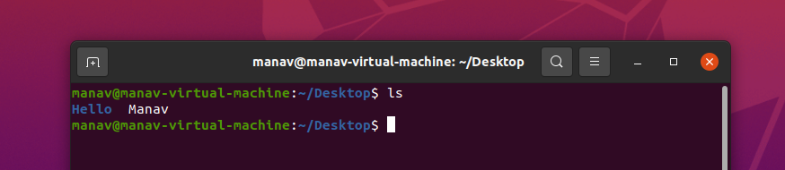

**2. cd** - cd command is known as change directory command. It is used to change current working directory.

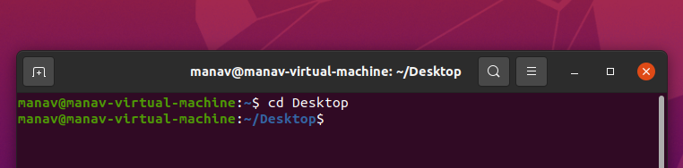

**3. pwd** - pwd stands for Print Working Directory. It prints the path of the working directory, starting from the root. pwd is shell built-in command(pwd) or an actual binary(/bin/pwd). $PWD is an environment variable which stores the path of the current directory.

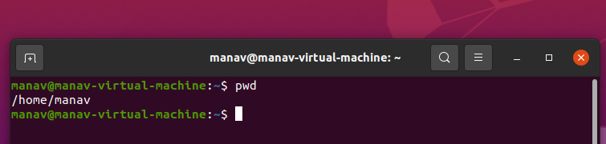

**4. cat** - Reads data from the file and gives its content as output. It helps us to create, view and concatenate files.

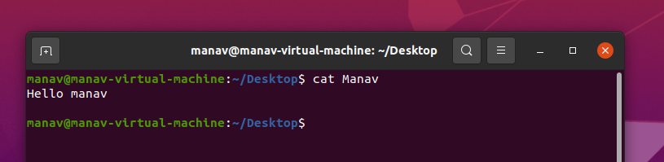

**5. mkdir** - mkdir command in UNIX allows the user to create directories (also referred to as folders in some operating systems). This command can create multiple directories at once as well as set the permissions for the directories.

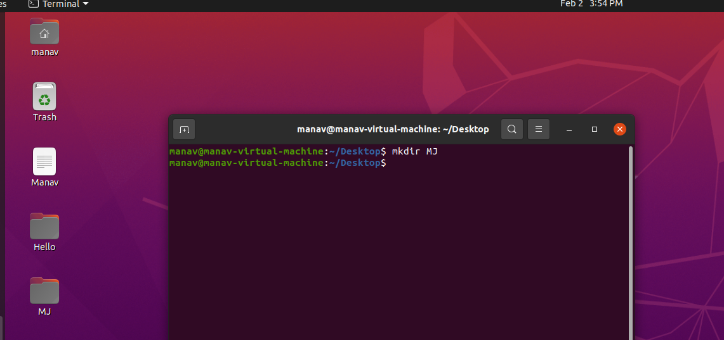

**6. rmdir** - rmdir command is used remove empty directories from the filesystem in UNIX. The rmdir command removes each and every directory specified in the command line only if these directories are empty. So if the specified directory has some directories or files in it then this cannot be removed by rmdir command.

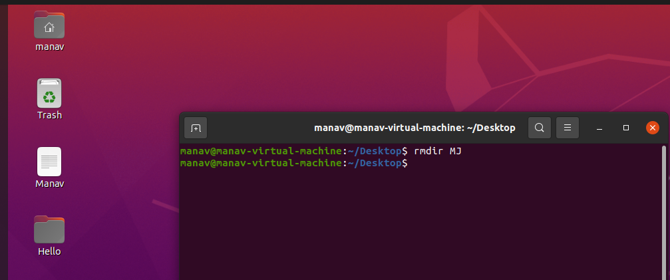

**7. cp** - cp stands for copy. This command is used to copy files or group of files or directory. It creates an exact image of a file on a disk with different file name. cp command requires at least two filenames in its arguments.

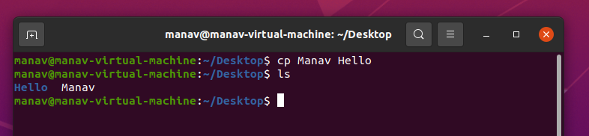

**8. wc** - The wc command in UNIX is a command line utility for printing newline, word and byte counts for files. It can return the number of lines in a file, the number of characters in a file and the number of words in a file. It can also be combined with pipes for general counting operations.

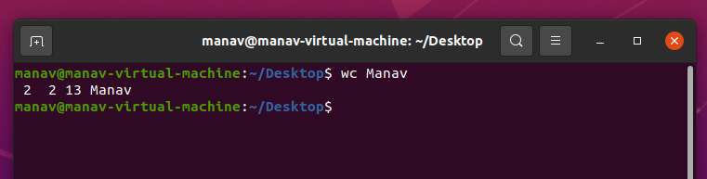

**9. grep** - The grep filter searches for a file for a particular pattern of characters, displays all lines that contain that pattern. GREP stands for Globally search for Regular Expression and Print.

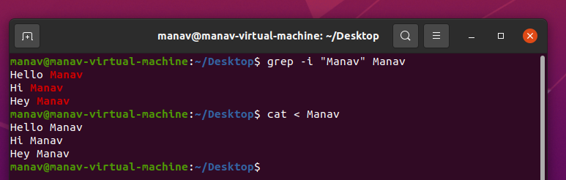

**10. tr** - The tr command in UNIX is a command line utility for translating or deleting characters. It supports a range of transformations including uppercase to lowercase, squeezing repeating characters, deleting specific characters and basic find and replace. It can be used with UNIX pipes to support more complex translation. Tr stands for translate.

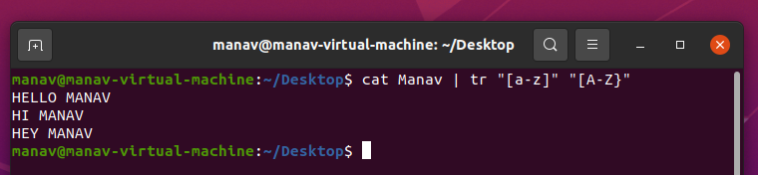

**11. sort** - Command used to sort a file, arranging records in a particular order. By default, the sort command sorts file assuming the contents are ASCII. Using options in sort command, it can also be used to sort numerically.

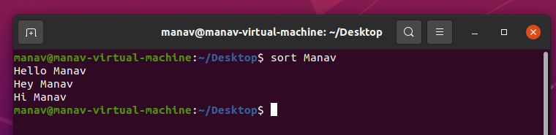

**12. file** - The file command is used to determine the type of a file. It may be human-readable or MIME type. This command tests each argument in an attempt to categorize it.

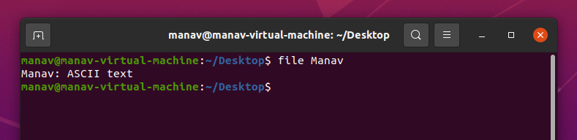

**13. mv** - Used to move one or more files or directories from one place to another in a file system like UNIX. 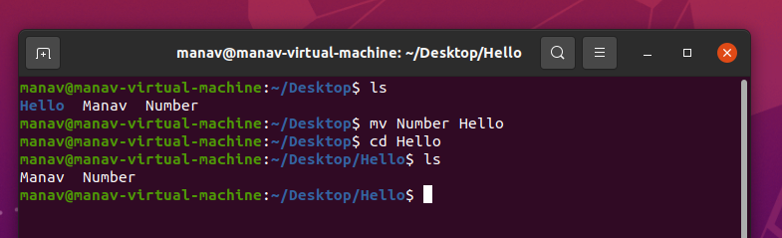

**14. Piping** - A pipe is a form of redirection (transfer of standard output to some other destination) that is used in UNIX and other Unix-like operating systems to send the output of one command/program/process to another command/program/process for further processing. The Unix/UNIX systems allow stdout of a command to be connected to stdin of another command. You can make it do so by using the pipe character ‘|’.

Pipe is used to combine two or more commands, and in this, the output of one command acts as input to another command, and this command’s output may act as input to the next command and so on. It can also be visualized as a temporary connection between two or more commands/ programs/ processes. The command line programs that do the further processing are referred to as filters.

**Conclusion:** We have understood how to execute the commands of File System Management of UNIX.